Dhrumil Patel, David Walji, Andrew Liang _______________

**Introduction:** Claire, a Great Dane, is experiencing extreme weight loss and lethargy despite maintaining a normal appetite. As a veterinary technician, you must learn about metabolism, digestion, and enzymes to help Claire. As part of this Gizmo, you will examine Claire, run lab tests, and analyze data to determine the cause and treat her weight loss.

**K: _____/8 T: _____/10 C: _____/9 A /9**



**Student Guide: Enzymes - AP STEM Case and Handbook**

**Vocabulary**: As new vocabulary is introduced, the words are presented in the Gizmo as **orange text** - clicking the orange text opens the glossary page for that term. You can use the glossary at any point.

**Rephrase answers in your own words to avoid plagiarism!**

1. Launch the Gizmo and follow the instructions provided to collect data on Claire. The questions below are sequential.

**Look under Case -> Patient info**

1. 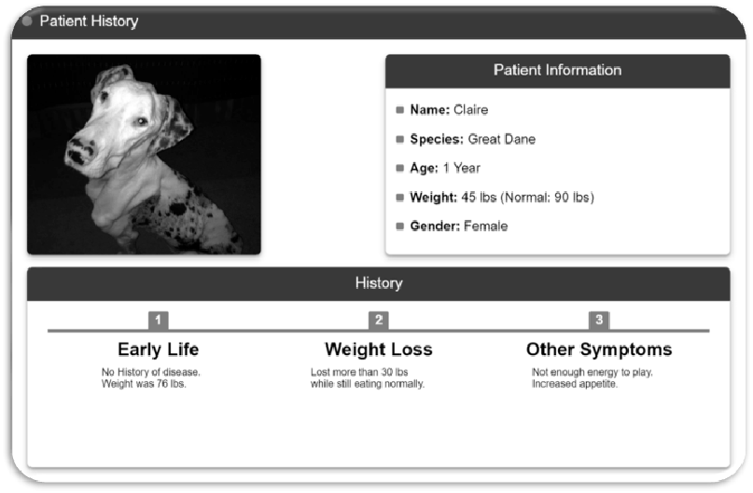What are Claire's symptoms?

**[C: 3]**

|  |
| --- |
| Increased appetite |
| Severe weight loss despite increased eating |
| Low energy – not enough to play |

1. Define "metabolism"

**Rephrase in your own words. [K: 1]**

**[K: 2]**

**Hint: Click on Handbook -> Metabolism, then follow the triangular arrow at the bottom right corner of the simulation window (beside Glossary).**

Metabolism is the a vital process for maintaining homeostasis in animals. It refers to many chemical reactions that happen in the body, which either combine or break down molecules.

1. **Metabolism** is a combination of two types of reactions. What are these? Define them.

|  |  |
| --- | --- |
| type of reaction | definition |
| Catabolic reactions | These reactions reduce food into smaller chunks (digestion). |
| Anabolic reactions | These reactions build upwards, typically building muscle. |

1. 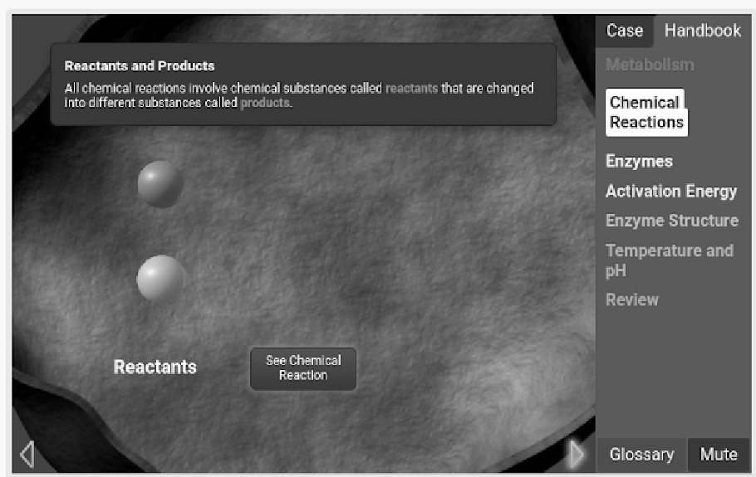What type of reaction is given in the "Chemical Reactions" example?

**[A: 1]**

An anabolic reaction, since the reactants combine to form a new product.

1. The reaction rate is the amount of product produced in a specific time. Why is reaction rate important for biological organisms?

**[A: 1]**

Organisms require high reaction rates to survive and grow. Without a fast reaction rate, organisms would be unable to digest food quickly enough to sustain their body’s energy needs. Moreover, organisms require high reaction rates to grow.

1. "Enzymes are biological **catalysts**". What does this mean?

**[K: 1]**

Catalysts increase the reaction rate of chemical reactions by lowering the activation energy required for a reaction to occur. Enzymes are catalysts in living organisms, making them biological catalysts.

1. Every chemical reaction, including the reactions that happen inside a living organism, requires an initial input of energy. The energy needed to start a chemical reaction is called the

**[C: 1]**

Activation Energy

1. Several different types of energy can be used to "give" a reaction its activation energy. List these below:

**[C: 2]**

thermal: heat energy that can increase the energy of the reaction

*collision*

*thermal::*

collision: sufficiently energetic collisions between reactants can break chemical bonds, which is energy that can be used to overcome a reaction’s activation energy.

1. In biological organisms thermal energy cannot be easily added to start a reaction. Instead, enzymes are used. Explain HOW enzymes speed up the rate of a reaction.

**[T: 2]**

The reactants attach to the enzyme and the enzyme lowers the activation energy of the reaction, reducing the amount of energy required to produce products. In the same amount of time, enzymes can facilitate more reactions, increasing the reaction rate.

1. Label the reaction graph provided with the following labels:

**[C: 3]**

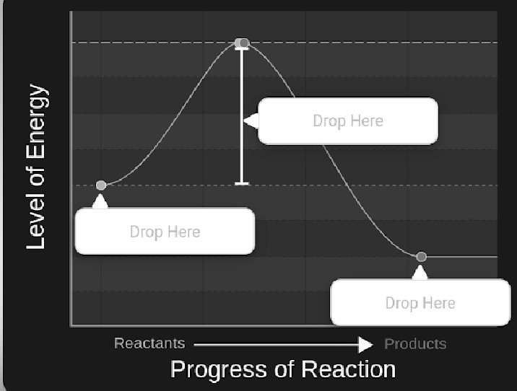

# activation energy, reactant energy, produce energy.

|  |  |
| --- | --- |
| a) | Reactant Energy |
| b) | Activation Energy |
| c) | Product Energy |

1. Fill in the blank:

Enzymes do not change the energy of the reactants or the products. They speed up a reaction by lowering the energy of….

**[K: 1]**

activation.

1. Each of your 80 000 enzymes has its own highly specific shape, its **structure**. What determines the

structure of an enzyme?

**[A: 1]**

To minimize space, the amino acids fold into a specific shape that becomes the structure of the enzyme. The folding is dictated by complex repelling and attracting interactions between amino acids.

1. Because of their specific structure, enzymes differ from each other. Every enzyme has a different **active site.** What happens at the active site of an enzyme? Can the **substrate** of one enzyme fit into the active site of another?

**[A: 2]**

At the active site, reactants are converted into products. Reactants must have a complementary shape to an enzyme’s active site to fit into it. Thus, substrate that fit into one enzyme’s activation site may not fit into another’s activation site.

1. How do high temperature and pH changes affect the workings of an enzyme? Explain.

**[T: 2]**

High temperature and pH can change the shape of the enzyme; certain substrate can no longer fit within the enzyme. In extreme cases, the enzymes can denature and sometimes are then unable to perform their original function. By changing shape, enzymes may perform other, undesired functions that could be disastrous. The risk of denaturing enzymes because of high temperatures is part of why extremely high fevers can be serious – the body raises its temperatures to, in part, denature a bacteria’s/virus’ proteins, but a fever too high may begin to denature our proteins and enzymes, which can be catastrophic.

1. Once you are back to Claire's Lab Data, fill in the table below:

**[K: 3]**

|  |  |  |
| --- | --- | --- |
| enzyme | location | function |
| *pepsin* | Lining of Stomach | Pepsins break down proteins and work best at a low pH |
| *protease* | Small Intestine | Protease break down proteins and food in small intestine. |
| *carbohydra se* | Small Intestine | Carbohydrase breaks down carbohydrates in the small intestine. |
| *lipase* | Small Intestine | Lipase breaks down lipids in the small intestine. |

1. Low enzyme function can be caused by a range of issues. In your Gizmo, explain how each of these could affect enzyme function and what happens when you test these in Claire.

**[T: 3]**

|  |  |  |
| --- | --- | --- |
| Potential issue | explanation | Claire's results |
| active site mutation | One of the amino acids that make up the enzymes can mutate, leaving the active site unable to accept the desired protein. This can stop the enzyme from performing its intended functions. | Claire’s enzymes seem to have no active site mutation. There are 100% shape matches between the protein and the enzyme. |
| abnormal pH | An abnormal pH can prevent enzymes from performing their original tasks | The pH in Claire’s stomach and intestines were within acceptable bounds for optimal pH for protease, lipase, and carbohydrase |
| low enzyme production | With too few enzymes, the reaction rate is too low, resulting in food being broken down very slowly. | Claire’s enzyme production is much lower than the enzyme production of healthy dogs, suggesting an inability to properly digest her food. |

1. Science function by asking and testing questions. As more information becomes known new questions can be asked and hypotheses can be revised to make them more and more accurate. At some point, once enough information has been gathered, a conclusion can be made. Explain how this Gizmo illustrates that process.

**[T: 3]**

The Gizmo illustrates the scientific method by explaining the background information about enzymes. Armed with our new understanding of enzymes, we make a hypothesis about Claire’s unusual behavior. We then conduct experiments and collect data to isolate the problem to Claire's small intestine. Using the data and previous studies about how the data relates to metabolism, we are able to determine whether the data rejects or fails to reject our hypothesis. Finally, after all tests have been done, a conclusion is found, and the problem is exposed - Exocrine Pancreatic Insufficiency. A prescription and treatment are given and followed. The Gizmo did a very good job of demonstrating the scientific method and current practices in medicine.

1. Optional extension:

As more evidence gathers, science is replaced by better science. Use a real-life example to explain this. As a good starting point, ave a look at:

**have a look at:**

<https://www.sciencenews.org/article/coronavirus-covid-19-pandemic-six-months-what-we-know>

**[A: 4]**

As the coronavirus ravaged our communities, the need for more knowledge about the virus became apparent. When SARS-CoV-2 had first been identified, little was known about how sick patients would infect healthy individuals, where the virus infects, and who is at most risk of developing severe disease. After many studies into SARS-CoV-2’s behavior, scientists are able to re-evaluate prior assumptions and have determined that: the virus can pass between humans even before symptoms appear, SARS-CoV-2 both infects deep in the lungs and in the nose, there is a much wider range of symptoms, particularly gastrointestinal symptoms, and that everyone should wear masks to slow the spread of the virus.

Bogna Haddad @ OCDSB, August 2020